Descriptive Statistics:

Min:

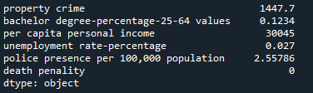

Max:

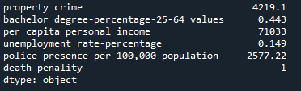

Mean:

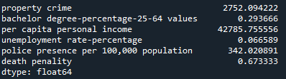

Standard Deviation:

